Pertrolium=>
- Gasoline-gasoline Asphalt-Asphalt Bitumen
- Automotive Gasoil
- MAZUT-100, 75, 99, etc.
- Murban Crude Oil
- D-2-Diesel and Products Crude Oil
- Refined Products
- Gas Oil "EN-590"
- RGD Regular Grade Diesel
- PGD Premium Grade Diesel (HSD)
- SGD Super Grade Diesel
- Regular Petrol RON 87 Premium Petrol RON 93
- Unleaded Petrol RON 95
- Super Premium RON 97
- HFO Heating Fuel Oil
- HSFO High Sulphur Fuel Oil LSFO Low Sulphur Fuel Oil
- Sulphur
- Bitumen \ Petroleum Asphalt 180CST
- GASOLINE all Grades

Solar Energy: => Solar (Panel) middle and big Projects (China and Europe Origin)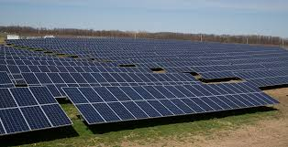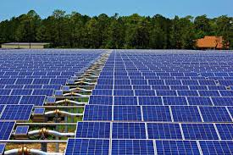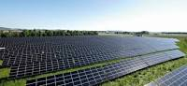

Wind Energy: => Europe Origin

Water Energy: => Europe Origin

